Operational policies provide a framework for consistent application and interpretation of matters by Wimmera CMA. Operational policies are not intended to be applied inflexibly in all circumstances. Individual circumstances may require a modified application of policy.

BACKGROUND & PURPOSE

These procedures outline the business rules that facilitate the smooth and safe operation of the Wimmera CMA business premises and ensure that a professional image of the organisation is presented.

These procedures apply to all Wimmera CMA staff and tenants.
Table of Contents
BACKGROUND & PURPOSE 1
PROCEDURES 3
OFFICE HOURS 3
LOCKING THE OFFICE 3
VISITORS 3
DRESS 3
NAME BADGES 3
ABSENCE FROM WORK 4
TELEPHONES 4
Voice Mail Setup and call redirection 4
Answering Calls as Reception 5
OUTLOOK 6
Email: 6
Out of Office Assistant 7
Calendars: 7
CORRESPONDENCE 7
TEMPLATES 8

PROCEDURES

OFFICE HOURS
The office is open to the public between the hours of 8:30 am and 4:30 pm Monday to Friday. Staff can arrange appointment times outside of these hours but will need to meet their visitors in reception.

LOCKING THE OFFICE

The front door is electronically programmed to lock outside of business hours, it will automatically lock at 4.30 pm and unlock at 8.30 am Monday to Friday. Outside of these hours and on weekends and public holidays, the door is programmed to remain locked.

Should there be a power outage, the front door will remain locked. Access to the building will require your key – please ensure that you relock the door upon exiting the building.

All staff leaving or entering the office via the front door outside of business hours are required to check that it is locked and secured on their way out.

The internal entry door at the front desk should remain closed at all times for security reasons.

Downstairs Kitchen Door (to access the toilets) – as this is access to a shared space; we need to ensure that the office is secure at all times. This door needs to remain closed and should be checked that it is secure at the end of the day.; This door is accessible using the swipe card, or a key – with a lanyard hanging on the fridge available for visitors. This also applies to the passage door near the photocopier downstairs.

Fire Escape access upstairs – external access to the building using this door has been removed. This exit should only be used in an emergency.

If, for any reason, one of the external doors is unable to be secured, please contact Nicole Netherway (Business Manager) or David Brennan (CEO) to determine the best course of action. If the lock has failed, they will contact Wynns Locksmiths 24-hour service on 5382 3819. (0409 538 238) and if the matter relates to the security system, contact CHS.

VISITORS
On arrival, all visitors to the inner office should be signed in at the front desk and signed out on departure by the staff member meeting them at the door. In the event of an evacuation of the building, this log can be used as a point of reference to assist in accounting for all personnel and visitors within the premises.

Externally contracted staff or stakeholders renting office space should ensure that the wall-mounted In/Out Board in the reception area is up to date with the names of staff members who operate from the office.

DRESS
It is expected that staff dress to a presentable standard at all times. When dealing with the public, staff members are encouraged to wear uniform and/or name badge.

Please refer to the Uniform Policy.docx

NAME BADGES
All staff are provided with name badges on commencing work with Wimmera CMA. Staff members are encouraged to wear their name badges when dealing with the public and representing the Wimmera CMA.
Name badges will only have employees’ first name – or preferred name.

ABSENCE FROM WORK
If an employee is unable to attend work for any reason, they must contact and inform their Manager/Supervisor of their non-attendance as soon as possible and preferably by 9 am on the day of absence.

If due to ill health or for other agreed arrangements a staff member has arranged with their Manager to work from home, – this should also be communicated to all staff via email and calendars updated as to their availability Why a staff member is not in the office does not need to be communicated; however staff members must be clear in the message if they are working from home and available or not available.

If the Manager or Supervisor is unavailable, a message should be left at reception. This message should be relayed to the relevant Manager / Supervisor as soon as possible. A courtesy email should then be sent to all staff noting their colleague’s absence.

In the event of a staff member leaving the office during business hours for personal reasons or illness, it is the responsibility of the staff member to ensure their calendar has been updated and the relevant Supervisor/Manager is informed prior to them leaving the office.

When leave is known in advance, leave requests are to be submitted and approved through Connx, calendars should be updated to indicate duration of absence from the office. Where remote access is available, staff should update calendars with their availability.

TELEPHONES

Wimmera CMA has Teams calling configured as the phone system – A Teams calling licence is included with E5 Microsoft Accounts, with each staff member allocated a direct number in the 5382 99** range of numbers.

Meeting rooms do not have a dedicated phone number allocated (however you can access Teams on any device logged into Teams taken into a meeting room)
Note: at NO time should you login to the Board room TV or the tablet operating the TV – it has its own user – boardroom.- you can make calls from the console.

All staff have a head set allocated and can answer calls on their computer; or through the Teams app on a mobile phone.

Teams calling has 2 “hunt groups”. These have nominated staff in each group:
Hunt group 1 – Corporate Staff
Hunt group 2 – All staff

All staff are requested to assist with call management by either answering and redirecting the call or taking a message if it rings at your desk.

Settings for Teams calling can be found by selection “don’t forward” in the bottom left hand corner of the Teams calling screen; or by clicking on the user in the top right hand corner and selecting Manage account.

Tips on how to configure or operate Teams calling can be found in Teams – WCMA All Staff – Teams Calling Updates

Voicemail Setup and call redirection

Staff are required to setup either voicemail or call redirection for all incoming calls to their number.

Staff can nominate for all unanswered calls to be sent to
- their voicemail (see settings below) or,
- their mobile phone

Voicemail can be either recorded or a message typed in and the system will read it to the caller.

Voicemail must be activated on Teams and/or your mobile phone –

Consider one of the options below-
Greeting A: You have reached the voicemail of Fred Smith at the Wimmera CMA. * Please leave your name, number and a brief message and I will get back to you as soon as possible. Thank you
Alternative Greeting A: You have reached the voicemail of Fred Smith at the Wimmera CMA. *You may contact me on my mobile ###### - please leave your name, number and a brief message and I will get back to you as soon as possible. Thank you

Part time staff (not in the office every day) – You have reached the voicemail of Fred Smith at the Wimmera CMA. * I am in the office on Mondays and Tuesdays. Please leave your name, number and a brief message and I will get back to you as soon as possible. Thank you
Leave: you have reached the voicemail of Fred Smith at the Wimmera CMA – I am currently on leave and will return your call upon my return – if the matter requires an immediate response, please contact the office on 53821544.

Out of office
If on leave for more than two days, the voice mail message should indicate this and provide an alternative contact for callers to speak to.
- As a positive reflection on the CMA, all calls should be responded to within one business day of the message being received, unless the employee is on leave or working away from the office.
- Where possible all staff should be promoting their direct lines to external parties. Direct lines are prefixed by 538299** and are displayed below your keypad in Teams (and in your email signature)

Redirection of Calls:
You can also redirect your call to another staff member or to reception (however, please discuss with them before doing this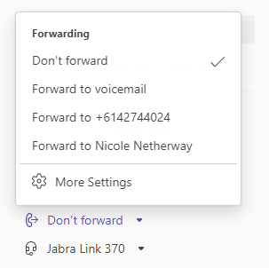

Answering Calls as Reception

Operator call group members should answer operator calls:

“Good morning/Good afternoon, Wimmera CMA this is………… “

Select Consult then transfer
- Announce the caller before transferring

If you are not confident with the use of the system, take a message – and provide details for the staff member to follow up.

Helpful hints:
- If the staff member does not answer, it can be helpful to check their Outlook calendar to obtain an idea of their availability to return a call,
- If attempting to direct a call and you are not given the option to select the staff members phone number– they are on a call or in a Teams meeting; and subsequently not available. (The call will go straight to voicemail)

- Callers should be encouraged to leave a voicemail message for the person they wish to speak to.
- If the caller does not wish to leave a message, the operator is to take the caller’s full name, phone number and what the call is regarding and email the staff member to ask them to return the call.

OUTLOOK

Email:
Email is deemed to be a legal document. Care should be taken when drafting emails as they contain the Wimmera CMA address – this applies to any personal correspondence as well.

To ensure a professional and consistent approach across the organisation with regards to our branding and messaging, the email signature on all emails is centrally maintained and automatically attached when the email is sent using a licensed program - Exclaimer. Any requests for updates to your information should be requested via email to the Business Manager.

Variations to the template may be granted with the approval of the CEO or Management Team; this option is not available for individuals but rather a blanket change to the template.

Examples of variations include promotions, advertising upcoming events and acknowledgments.

The template should be consistent with current marketing and style guides. The following information should be included in any template:
- Employee name; position title
- Direct & mobile contact numbers
- Days of work if part time
- Office address and website
- Links to social media sites
- WCMA logo

Out of Office Assistant
This should be used for all absences greater than two (2) days or where you may be expecting a volume of emails – both internally and externally

Your out of office response needs to include when you are likely to respond and an alternative contact should the matter be urgent:

I am on leave, returning Monday October 1st. I will respond to your email upon my return. If the matter is urgent, please contact Joe Bloggs in this office on 53821544 or bloggsj@wcma.vic.gov.au.

Calendars:
Staff regularly refer to staff Outlook calendars when answering incoming calls, dealing with customer enquiries, scheduling meetings and training. All staff should ensure their calendars are up to date at all times;
- Any leave, changes to working days or meetings should be updated;
- If arrangements are in place to work from home, be sure to include this in your calendar along with your availability
- Part-time staff should block out the days they do not work (and times when they work shorter days) between 8:30 am and 5:00 pm as a recurring appointment. Staff whose standard day is outside these hours but still between 7:00 am and 7:00 pm can either set their calendars to display a longer working day in settings or indicate the hours by booking an appointment all day and marking the time as free (the subject will then appear at the top of the screen.)
Do not block out the days you work as this shows you as unavailable and staff are unable to book meetings with you (the calendar will display as busy) – this will also impact on Teams calling and your settings for messaging in Teams.

TEMPLATES

For everyday office use, there are a set of templates composed for both ease of use and professional purposes.

Templates are available in SharePoint Online Business Processes – Templates.
Policies - Templates - All Documents

Templates which are regularly used are also located in the Microsoft products that they were created in – for example, Word;
File / New / More templates / Wimmera Catchment Management Authority
(see screenshots below)
For frequently used templates you can pin these to the top.

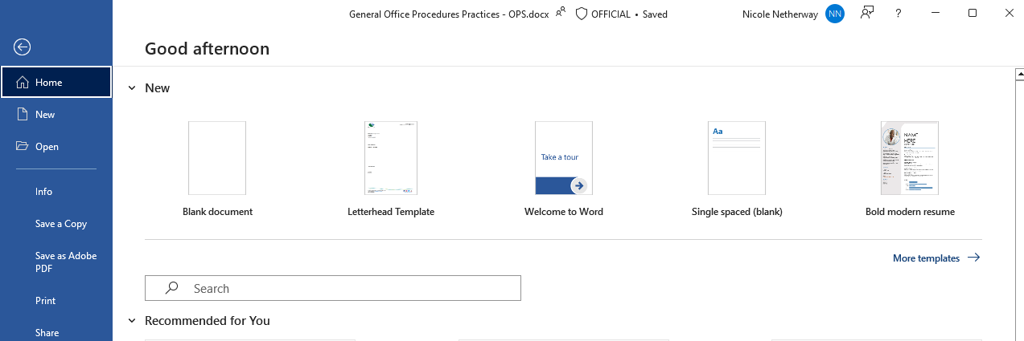

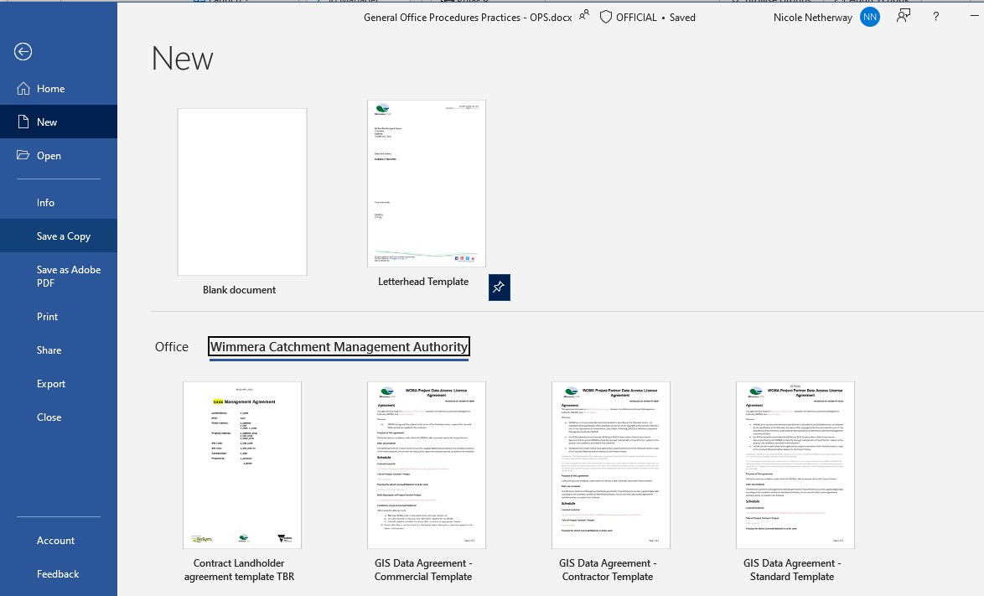

OTHER RELEVANT POLICIES
Document Management Business Rules Policy Procedure .docx
Uniform Policy.docx

